

Student Task Management System

A PROJECT REPORT
Submitted by

Shalini Pandurang Shanbhag - 1BM24MC086
In partial fulfilment for the award of the degree of

MASTER OF COMPUTER APPLICATIONS

Under the guidance of

Internal Guide

Prof. Dr. D.N. Sujatha
Professor
Dept. of Computer Applications
B.M.S. College of Engineering, Bengaluru – 560019



B.M.S. COLLEGE OF ENGINEERING

(Autonomous Institution under VTU)
Bull Temple Road, Basavanagudi, Bengaluru – 560019
JUNE 2026

B.M.S. COLLEGE OF ENGINEERING
BENGALURU-19
Department of Computer Applications


CERTIFICATE

This is to certify that the report entitled “Student Task Management System” submitted in the partial fulfilment of the requirement of the degree of MASTER OF COMPUTER APPLICATIONS is the result of the bonified work carried out by Shalini Pandurang Shanbhag (1BM24MC086) during the academic year 2025-2026.

Signature of Guide Signature of HoD

……………………………………….. ……………………………………..

Dr. D N Sujatha Dr. S Uma
Professor Professor & Head
Department of Computer Applications Department of Computer Applications
B.M.S. College of Engineering B.M.S. College of Engineering
Bengaluru-560019 Benagluru-560019

Examiner 1: Examiner 2:
…………………………………………….. ………………………………………..

…………………………………………….. …………………………………………

ACKNOWLEDGEMENT

I would like to express my heartfelt gratitude and appreciation to all those who contributed to the successful completion of this project. Their assistance, insights, and guidance have been instrumental in shaping the development of this project. This endeavor would not have been possible without the collective efforts, guidance, and support of numerous individuals and resource.
First, I would like to thank my internal guide Prof. Dr. D N Sujatha, Professor Department of Computer Applications, B.M.S. College of Engineering for her constant support and guidance in preparing this report.
Next, I would like to thank Dr. S. Uma, Professor & Head, Department of Computer Applications, B.M.S. College of Engineering for her guidance and support.
I also wish to place my deep debt of gratitude to Dr. Bheemsha Arya, Principal, B.M.S. College of Engineering for his constant help.
This project has been the remarkable journey of discovery, growth, and collaboration. I would also like to thank my parents and friends for their support and guidance.

Shalini Pandurang Shanbhag 1BM24MC086

ABSTRACT
The project titled “Student Task Management System” is a modern web-based productivity and academic management system developed to help students efficiently organize tasks, monitor academic activities, and analyze their overall performance through an interactive dashboard. In today’s academic environment, students often face difficulties in managing assignments, project deadlines, examinations, and daily study schedules due to the absence of a centralized and intelligent tracking platform. Traditional methods such as notebooks, spreadsheets, or simple reminder applications lack analytical capabilities, real-time accessibility, and performance monitoring features. This system aims to overcome these limitations by providing a secure, cloud-based solution that combines task management with productivity analytics.
The proposed system allows users to register and securely log in using authentication mechanisms. Students can create, update, categorize, prioritize, and track academic tasks based on deadlines and completion status. The application also provides productivity insights through visual dashboards, enabling users to analyze completed tasks, pending activities, overdue work, and category-wise performance trends. These analytical features help students improve time management, academic planning, and overall productivity.
The system is developed using modern full-stack technologies including Java Spring Boot for backend development, React.js for frontend development, and MySQL for database management. RESTful APIs are used for communication between frontend and backend components, while JWT (JSON Web Token) authentication ensures secure access control and protected user sessions. The application is deployed on cloud platforms, making it accessible anytime and from any location.
The project follows a modular and scalable software architecture that supports future enhancements such as AI-based task recommendations, mobile application integration, calendar synchronization, reminder notifications, and collaborative task management. The implementation of dashboards, analytics, authentication, and responsive design makes the system more advanced than traditional task management applications.
The “Student Task Management System” not only simplifies academic task management but also provides meaningful productivity insights that assist students in improving efficiency, reducing missed deadlines, and achieving better academic performance.

TABLE OF CONTENTS

INTRODUCTION

1.1 Overview
The “Student Task Management System” is a web-based academic productivity management system designed to help students effectively organize, monitor, and analyze their academic activities. The system provides a centralized platform where students can manage assignments, projects, examinations, and daily tasks in a structured manner. Along with task management, the system includes analytical dashboards that help users track productivity and performance trends.
The application is developed using modern web technologies such as Node.js, React.js, and MySQL. It follows a client-server architecture where the frontend interacts with backend REST APIs to perform operations such as task creation, authentication, filtering, and analytics generation. Since the application is cloud-based, users can access their academic information securely from anywhere and at any time.

1.2 Problem Statement
Students commonly face challenges in organizing academic tasks, managing deadlines, and monitoring their productivity levels. Existing manual methods such as notebooks, sticky notes, or basic reminder applications do not provide intelligent tracking or performance analysis. As a result, students often experience:
- Missed assignment deadlines
- Poor time management
- Lack of productivity insights
- Difficulty in tracking academic progress
- Improper prioritization of tasks
Most existing systems focus only on simple task storage and lack advanced analytical capabilities such as productivity dashboards, overdue analysis, and category-based performance tracking. Therefore, there is a need for a smart, cloud-based system that not only manages academic tasks but also helps students analyze and improve their productivity.

1.3 Objectives
The main objectives of the proposed system are:
- To develop a centralized academic task management system for students.
- To enable students to create, update, delete, and organize tasks efficiently.
- To implement secure authentication and user management using JWT.
- To provide category-based task tracking and prioritization.
- To generate productivity analytics and performance dashboards.
- To improve academic planning and deadline management.
- To provide cloud accessibility for anytime and anywhere usage.
- To design a scalable system that supports future enhancements.

1.4 Scope of the Project
The scope of the project includes the development of a secure cloud-based web application for academic task and productivity management. The system focuses on helping students manage their educational activities through dashboards, categorization, and performance tracking.
The project includes:
- User authentication and authorization
- Task creation and management
- Category-wise task organization
- Productivity analytics dashboards
- Search and filtering functionalities
- Cloud deployment and accessibility
The system can be further expanded in the future by integrating:
- AI-based recommendations
- Mobile applications
- Notification systems
- Calendar synchronization
- Collaborative task sharing

1.5 Methodology
The development of the project follows a systematic software engineering methodology consisting of multiple phases:

Requirement Analysis
Understanding user requirements, identifying problems in existing systems, and defining project objectives.

System Design
Designing database schemas, architecture diagrams, REST APIs, and frontend interfaces.

Backend Development

Developing backend services using Node.js and Express.js, implementing REST APIs, authentication mechanisms, and database connectivity for handling task management, user operations, and category-based analytics.

Frontend Development
Building responsive user interfaces using React.js and integrating them with backend APIs.

Testing
Performing unit testing, API testing, authentication testing, and validation testing to ensure system reliability.

Deployment
Deploying the frontend, backend, and database on cloud platforms for online accessibility.

1.6 Advantages of the Proposed System
The proposed system offers several advantages over traditional task management methods:
- Centralized management of academic tasks
- Secure cloud-based accessibility
- Interactive productivity dashboards
- Improved deadline tracking
- Better task prioritization
- Enhanced student productivity analysis
- Scalable and modular architecture
- User-friendly and responsive interface

1.7 Technologies Used
The major technologies used in the project are:
Technology | Purpose
Node.js | Backend Development
React.js | Frontend Development
MySQL | Database Management
JWT Authentication | Security & Authentication
REST APIs | Frontend-Backend Communication
HTML/CSS/JavaScript | UI Design
Cloud Hosting Platforms | Deployment

1.8 Expected Outcomes
The expected outcomes of the project are:
- Efficient academic task organization
- Reduced missed deadlines
- Improved productivity management
- Better visibility into student performance trends
- Secure and reliable cloud-based access
- Enhanced academic planning and time management
The system is expected to help students maintain consistency in their academic work while also providing insights into their productivity patterns through analytical dashboards.

LITERATURE SURVEY

2.1 Introduction
A literature survey is an important part of software project development that helps in understanding existing systems, technologies, methodologies, and research related to the proposed project. The study of existing productivity systems and task management applications provides insights into their functionalities, limitations, and implementation techniques. This chapter discusses various existing task management and productivity tracking systems along with their drawbacks and explains how the proposed “Student Task Management System” improves upon them.
The rapid growth of cloud computing and web technologies has transformed the way productivity applications are developed and used. Users today require platforms that not only manage tasks but also provide analytical insights into productivity and work patterns. Existing systems provide basic task management functionalities but often fail to deliver detailed category-based analytics, visual dashboards, and intelligent productivity tracking.

2.2 Existing Systems
Several task management and productivity applications are currently available for users. Some commonly used systems include:

2.2.1 Traditional Task Management Systems
Traditional task management systems mainly focus on creating and organizing tasks using simple features such as:
- Task creation
- Reminder notifications
- Deadline tracking
- Checklists
Examples include simple to-do list applications and manual planners.

Limitations
- Lack of productivity analytics
- No category-based analysis
- Limited task organization features
- No intelligent performance monitoring
- Poor scalability

2.2.2 Cloud-Based Productivity Applications
Modern cloud-based productivity tools such as task planners and project management applications allow users to access tasks from multiple devices. These systems support:
- Real-time synchronization
- Cloud storage
- Collaboration features
- Responsive interfaces
Examples include:
- Trello
- Notion
- Google Tasks

Limitations
Although these applications are advanced, they still have several drawbacks:
- General-purpose design with limited productivity analysis
- Lack of detailed category-based tracking
- Minimal dashboard analytics
- Complex interfaces for simple task management
- Limited customization for analytical insights

2.2.3 Productivity Tracking Systems
Some productivity tracking systems focus on monitoring completed tasks and work schedules. These systems generally provide:
- Task monitoring
- Progress tracking
- Basic dashboards
- Scheduling support

Limitations
- Limited analytical visualization
- No advanced category-wise productivity analysis
- Lack of secure personalized tracking
- Minimal scalability features
- Poor integration between task management and analytics

2.3 Review of Technologies
The proposed system uses modern web technologies that are widely adopted in full-stack application development.

2.3.1 Node.js and Express.js Framework
Node.js is a server-side JavaScript runtime used for building scalable and efficient backend applications. In this project, Node.js is used along with Express.js to develop RESTful APIs and handle server-side operations.
Express.js simplifies backend development by providing routing, middleware support, and API management functionalities. The backend communicates with the frontend and database efficiently to perform operations such as authentication, task management, category analysis, and data processing.

Advantages
- Fast and scalable backend development
- Efficient handling of asynchronous operations
- Easy REST API implementation
- Lightweight and flexible architecture
- Smooth integration with React.js frontend
- Better performance for real-time applications
- Large ecosystem of libraries and packages

2.3.2 React.js
React is a frontend JavaScript library used for developing interactive and responsive user interfaces.

Advantages
- Component-based architecture
- Fast rendering using Virtual DOM
- Reusable UI components
- Improved user experience
- Efficient state management

2.3.3 MySQL Database
MySQL is used for storing application data such as user details, task information, and productivity records.

Advantages
- Structured data management
- High reliability
- Easy query handling
- Scalability and performance
- Secure data storage

SYSTEM ANALYSIS

3.1 Introduction
System analysis is the process of studying existing systems, identifying their limitations, and defining the requirements for a new and improved system. The purpose of this chapter is to analyze the problems faced in traditional task management methods and explain how the proposed “Student Task Management System” provides an effective solution through cloud technologies, category-based analytics, and modern web development frameworks.
The proposed system focuses on improving task organization, productivity tracking, and analytical visualization through a secure and user-friendly web application.

3.2 Existing System
Existing task management systems mainly focus on storing and displaying tasks without providing detailed analytical insights. Many users still rely on traditional methods such as notebooks, spreadsheets, or simple reminder applications to manage their daily activities and deadlines.
Some modern productivity applications provide basic task management and synchronization features, but they often lack meaningful category-based productivity analysis and simplified user-focused dashboards.

3.2.1 Drawbacks of Existing System
The major drawbacks identified in the existing systems are:
- Lack of centralized task organization
- Limited productivity analytics
- No detailed category-based analysis
- Difficulty in tracking completed and pending tasks
- Poor visualization of productivity trends
- Limited customization and filtering options
- Absence of secure personalized task management in basic systems
- Difficulty accessing data across multiple devices in offline systems
Due to these limitations, users often struggle with managing workloads efficiently and analyzing their productivity patterns.

3.3 Proposed System
The proposed “Student Task Management System” is designed to overcome the limitations of existing systems by providing a secure, scalable, and cloud-based productivity management platform.
The system enables users to:
- Create and manage tasks
- Organize tasks using categories
- Track task completion status
- Analyze productivity using dashboards
- View category-wise productivity trends
- Access the application securely from anywhere
The application combines task management and analytical visualization into a single integrated platform. It provides users with better insights into their productivity and task completion behavior.

3.4 Features of the Proposed System
The major features of the proposed system include:

User Authentication
- Secure user registration and login
- JWT-based authentication and authorization
- Protected routes and session handling

Task Management
- Add, update, and delete tasks
- Set task priorities and deadlines
- Mark tasks as completed or pending

Category Management
- Organize tasks into different categories
- Perform category-wise productivity analysis
- Improve task classification and tracking

Dashboard and Analytics
- Display productivity statistics
- Visualize completed and pending tasks
- Analyze overdue tasks
- Generate category-based charts and trends

Cloud Accessibility
- Access the system anytime and anywhere
- Store and manage data securely on cloud platforms

3.5 Advantages of Proposed System
The proposed system provides several advantages compared to traditional task management methods:
- Improved task organization
- Better productivity tracking
- Interactive analytical dashboards
- Secure authentication system
- Responsive and user-friendly interface
- Centralized cloud-based access
- Efficient category-wise analysis
- Scalability for future enhancements

3.6 Feasibility Study
A feasibility study helps determine whether the proposed system is practical and beneficial.

3.6.1 Technical Feasibility
The proposed system is technically feasible because it uses widely adopted and reliable technologies such as:
- Node.js
- Express.js
- React
- MySQL
These technologies support scalability, cloud deployment, responsive interfaces, and secure backend operations.

3.6.2 Economic Feasibility
The system is economically feasible because:
- Open-source technologies are used
- Development tools are freely available
- Cloud hosting platforms provide affordable deployment solutions
- Maintenance costs are minimal

3.6.3 Operational Feasibility
The application is operationally feasible because:
- The interface is simple and user-friendly
- Users can easily manage and track tasks
- The system improves productivity and organization
- Minimal training is required for usage

3.7 System Architecture Overview
The system follows a client-server architecture consisting of:
- Frontend Layer
  - Developed using React.js
  - Handles user interaction and dashboard visualization
- Backend Layer
  - Developed using Node.js and Express.js
  - Manages APIs, authentication, and business logic
- Database Layer
  - MySQL database for storing user and task information
- Cloud Deployment
  - Enables online accessibility and secure data storage
The frontend communicates with the backend through REST APIs, while the backend interacts with the database for data storage and retrieval.

3.8 Conclusion
The system analysis clearly shows that existing task management systems lack advanced analytical capabilities and efficient category-based productivity tracking. The proposed “Student Task Management System” provides a modern cloud-based solution that integrates task management, analytics, secure authentication, and responsive design into a single platform.
The use of modern full-stack technologies ensures scalability, security, reliability, and better user experience. The proposed system effectively improves productivity monitoring and task organization through interactive dashboards and category-based analysis.

PROJECT PLAN

3A.1 Introduction
The Project Plan outlines the schedule, phases, milestones, and resources involved in developing the "Cloud-Based Student Task & Performance Tracker". A well-defined project plan ensures that all development activities are completed in a structured, time-bound, and systematic manner. This plan was developed at the beginning of the project and updated throughout the development lifecycle to reflect actual progress.

3A.2 Development Methodology
The project follows an Iterative and Incremental Development methodology. The development is divided into clearly defined phases, each building upon the previous one. This approach allows for progressive refinement of features based on testing outcomes and review feedback.
The key phases followed in this project are:
- Phase 1: Requirement Analysis and Planning
- Phase 2: System Design and Architecture
- Phase 3: Backend Development
- Phase 4: Frontend Development
- Phase 5: Integration and Testing
- Phase 6: Deployment and Documentation

3A.3 Project Milestones
The following table lists the major milestones achieved during the project development:

Milestone | Description | Target Date | Actual Date | Status
M1 – Requirement Finalization | Finalize functional and non-functional requirements and SRS document | Week 2 | Week 2 | Completed
M2 – System Design Approved | Complete ER diagram, architecture, API design, and UI wireframes | Week 4 | Week 4 | Completed
M3 – Backend Development Complete | All REST APIs for user, task, analytics, and AI modules working | Week 8 | Week 9 | Completed
M4 – Frontend Development Complete | All React.js pages integrated with backend APIs | Week 11 | Week 12 | Completed
M5 – Testing Complete | Unit, integration, and system testing completed and bugs resolved | Week 13 | Week 13 | Completed
M6 – Cloud Deployment | Application deployed to cloud hosting environment | Week 14 | Week 14 | Completed
M7 – Documentation Complete | Final project report and appendices completed | Week 15 | Week 15 | Completed

3A.4 Project Schedule (Gantt Chart Summary)
The table below represents the project schedule across 15 weeks, showing which phase was active during each week of development:

Phase / Activity | W1 | W2 | W3 | W4 | W5 | W6 | W7 | W8 | W9 | W10 | W11 | W12 | W13 | W14 | W15
Requirement Analysis | ✓ | ✓
System Design |  |  | ✓ | ✓
Database Design |  |  |  | ✓ | ✓
Backend – User Module |  |  |  |  | ✓ | ✓
Backend – Task Module |  |  |  |  |  | ✓ | ✓ | ✓
Backend – Analytics & AI |  |  |  |  |  |  |  | ✓ | ✓
Frontend – Auth Pages |  |  |  |  |  |  | ✓ | ✓
Frontend – Dashboard |  |  |  |  |  |  |  | ✓ | ✓ | ✓
Frontend – Tasks & Planner |  |  |  |  |  |  |  |  |  | ✓ | ✓
Frontend – Analysis & AI |  |  |  |  |  |  |  |  |  |  | ✓ | ✓
Integration Testing |  |  |  |  |  |  |  |  |  |  |  | ✓ | ✓
System & UAT Testing |  |  |  |  |  |  |  |  |  |  |  |  | ✓
Cloud Deployment |  |  |  |  |  |  |  |  |  |  |  |  |  | ✓
Documentation & Report |  |  |  |  |  |  |  |  |  |  |  |  |  | ✓ | ✓

3A.5 Resource Plan
The following resources were utilized during the development of this project:

Resource Type | Resource | Purpose
Hardware | Personal Laptop (Intel Core i5, 16GB RAM) | Development and testing environment
Operating System | Windows 11 | Development platform
Backend Framework | Node.js + Express.js | REST API development
Frontend Framework | React.js + Vite | User interface development
Database | MySQL | Persistent data storage
AI Integration | Google Gemini 2.5 Flash API | AI-based task breakdown
Authentication | JWT (JSON Web Token) | Secure session management
Email Service | Nodemailer | Password reset and notifications
Version Control | Git / GitHub | Source code management
Deployment Platform | Cloud Hosting (Vercel/Render) | Application deployment
IDE / Editor | Visual Studio Code | Code development
API Testing | Postman | REST API validation

3A.6 Risk Management
The following risks were identified and managed during the project:

Risk | Impact | Likelihood | Mitigation Strategy
API integration failures | High | Medium | Tested all endpoints individually using Postman before integration
Database connectivity issues | High | Low | Used connection pooling and error handling in db.js configuration
JWT authentication bugs | High | Low | Thoroughly tested login and protected routes with expiry handling
Gemini AI API downtime | Medium | Medium | Implemented fallback mock data when API key is absent or fails
Cloud deployment failures | Medium | Low | Tested locally before deployment; configured environment variables on hosting platform
Scope creep | Medium | Medium | Defined clear scope in SRS; additional features deferred to Future Enhancements

3A.7 Conclusion
The project plan provided a structured framework for completing the "Cloud-Based Student Task & Performance Tracker" within the defined timeline. By following the iterative development phases, monitoring milestones, and managing risks proactively, the project was completed successfully. The schedule was largely adhered to, with minor delays in backend development resolved within the next sprint cycle.

REQUIREMENT ANALYSIS

4.1 Introduction
Requirement analysis is one of the most important phases in software development. It involves identifying, analyzing, and documenting the functional and non-functional requirements of the proposed system. This chapter explains the requirements needed for the development and successful implementation of the “Student Task Management System”.
The system is designed to provide secure task management, category-based analysis, productivity tracking, and cloud accessibility through a modern web application architecture.

4.2 Functional Requirements
Functional requirements define the core operations and functionalities performed by the system.

4.2.1 User Registration
The system should allow new users to create accounts by providing:
- Username
- Email ID
- Password
The system validates the entered information before account creation.

4.2.2 User Login
Registered users should be able to securely log in using valid credentials. The system verifies authentication using JWT-based authorization mechanisms.

Functions
- Validate user credentials
- Generate authentication token
- Allow secure session management

4.2.3 Task Management
Users should be able to:
- Add tasks
- Edit existing tasks
- Delete tasks
- Update task status
- Set deadlines and priorities
The system stores all task information in the database.

4.2.4 Category Management
The system should support:
- Creating task categories
- Assigning categories to tasks
- Organizing tasks based on categories
- Category-wise productivity tracking
This feature improves task organization and analysis.

4.2.5 Dashboard Analytics
The system should provide dashboard visualizations including:
- Total tasks
- Completed tasks
- Pending tasks
- Overdue tasks
- Category-wise analysis
- Productivity trends
The dashboard helps users monitor their productivity effectively.

4.2.6 Search and Filtering
Users should be able to:
- Search tasks
- Filter tasks by category
- Filter tasks by completion status
- Sort tasks based on deadlines or priorities

4.2.7 Secure Authentication
The application should implement:
- JWT authentication
- Protected routes
- Password encryption
- Secure session handling
This ensures data privacy and system security.

4.3 Non-Functional Requirements
Non-functional requirements describe the quality attributes and performance characteristics of the system.

4.3.1 Performance Requirements
- The system should respond quickly to user requests.
- Dashboard data should load efficiently.
- API response time should be minimized.

4.3.2 Security Requirements
- User data must be securely stored.
- Passwords should be encrypted before storage.
- Unauthorized users should not access protected resources.
- JWT tokens should be validated for each request.

4.3.3 Reliability Requirements
- The application should provide consistent performance.
- Database operations should maintain data integrity.
- System failures should be minimized.

4.3.4 Scalability Requirements
- The system should support future feature expansion.
- The backend should handle increasing numbers of users and tasks efficiently.
- Cloud deployment should support scalability.

4.3.5 Usability Requirements
- The user interface should be simple and responsive.
- Navigation should be easy for all users.
- Dashboard information should be visually understandable.

4.4 Hardware Requirements
The minimum hardware requirements for the system are:
Component | Requirement
Processor | Intel i3 or above
RAM | 4 GB minimum
Storage | 20 GB free space
Internet Connection | Required
Display | Standard Monitor

4.5 Software Requirements
Software | Purpose
Operating System | Windows/Linux
Node.js | Backend Development
Express.js | API Development
React | Frontend Development
MySQL | Database Management
Visual Studio Code | Code Editing
Browser | Application Testing
Git & GitHub | Version Control

4.6 System Requirements Specification (SRS)
The Software Requirement Specification defines the behavior and functionality of the proposed system.

Input Requirements
The system accepts:
- User registration details
- Login credentials
- Task information
- Categories
- Deadlines and priorities

Output Requirements
The system generates:
- Dashboard analytics
- Productivity charts
- Task status reports
- Category-wise analysis
- Filtered task lists

Process Requirements
The system processes:
- User authentication
- CRUD operations for tasks
- Data filtering and searching
- Dashboard calculations and analytics generation

4.7 Constraints of the System
The system may have the following constraints:
- Internet connection is required for cloud access
- Dashboard accuracy depends on user-entered task data
- Performance may vary depending on hosting platform resources

4.8 Conclusion
Requirement analysis helps in understanding the functionalities and quality attributes required for the successful implementation of the “Student Task Management System”. The identified functional and non-functional requirements ensure that the system remains secure, scalable, responsive, and user-friendly.
The use of modern technologies such as Node.js, Express.js, React.js, and MySQL supports efficient system development and future scalability while providing a reliable platform for productivity management and category-based task analysis.

SYSTEM DESIGN

5.1 Introduction
System design is the process of defining the architecture, components, interfaces, and data flow of a software system. It acts as a blueprint for the implementation phase and helps in organizing the development process efficiently. The “Student Task Management System” is designed using a modular client-server architecture that ensures scalability, maintainability, security, and responsiveness.
The system integrates frontend interfaces, backend APIs, authentication mechanisms, database connectivity, and analytical dashboards into a single cloud-based platform.

5.2 System Architecture
The application follows a three-layer architecture consisting of:
- Presentation Layer (Frontend)
- Application Layer (Backend)
- Database Layer
The frontend communicates with the backend through REST APIs, while the backend interacts with the database for storing and retrieving information.

5.2.1 Architecture Components

Frontend Layer
The frontend is developed using React and is responsible for:
- User interaction
- Dashboard visualization
- Forms and task management interfaces
- API communication

Backend Layer
The backend is developed using Node.js and Express.js.
Responsibilities include:
- Handling REST APIs
- User authentication
- Business logic implementation
- Data processing
- Category-based analysis generation

Database Layer
The system uses MySQL for storing:
- User details
- Task information
- Categories
- Productivity data

5.3 System Architecture Diagram
The architecture of the system can be represented as:
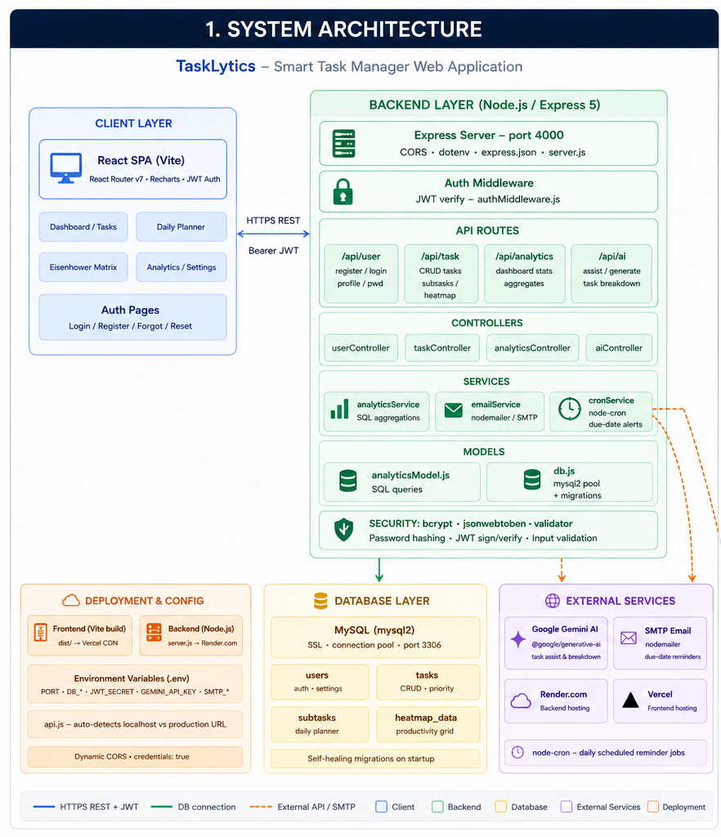
The frontend sends requests to backend APIs, and the backend communicates with the database to process and retrieve information.

5.4 Use Case Diagram
A Use Case Diagram represents the interaction between users and the system functionalities.

Actor
- User

Use Cases
- Register
- Login
- Add Task
- Update Task
- Delete Task
- View Dashboard
- Analyze Productivity
- Filter Tasks
- Manage Categories

Use Case Representation

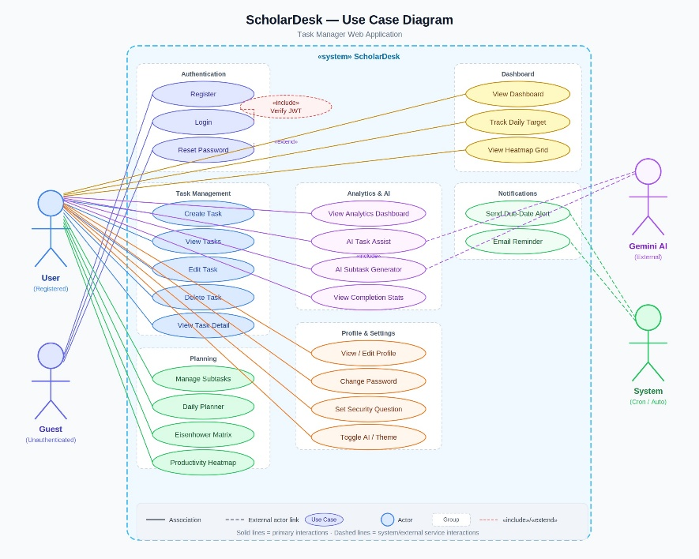

5.5 Data Flow Diagram (DFD)
A Data Flow Diagram shows how data moves within the system.

5.5.1 DFD Level 0
The Level 0 DFD represents the overall flow between users and the system.

Process Flow
- User sends request
- System processes request
- Database stores/retrieves data
- System returns response

DFD Level 0 Representation

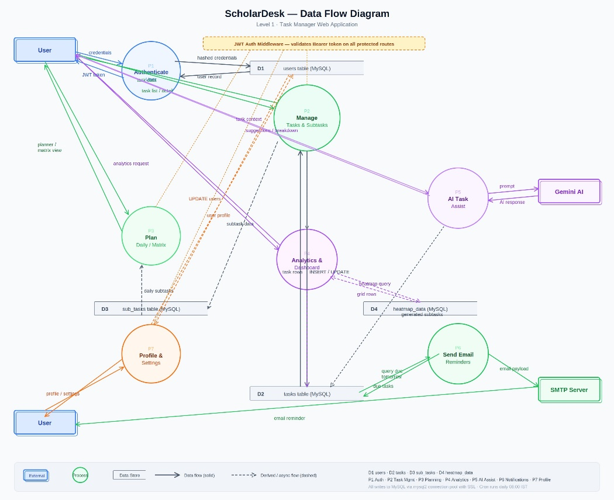

5.5.2 DFD Level 1
Level 1 DFD provides detailed internal processes.

Main Processes
- Authentication Processing
- Task Management
- Category Management
- Dashboard Analytics
- Database Operations

5.6 Entity Relationship (ER) Diagram
The ER Diagram represents the relationship between database entities.

Main Entities

Users Table
Stores:
- User ID
- Username
- Email
- Password

Tasks Table
Stores:
- Task ID
- Title
- Description
- Deadline
- Status
- Priority
- Category ID
- User ID

Categories Table
Stores:
- Category ID
- Category Name

Relationships
- One user can have multiple tasks
- One category can contain multiple tasks
- Each task belongs to one user and one category

ER Diagram Representation
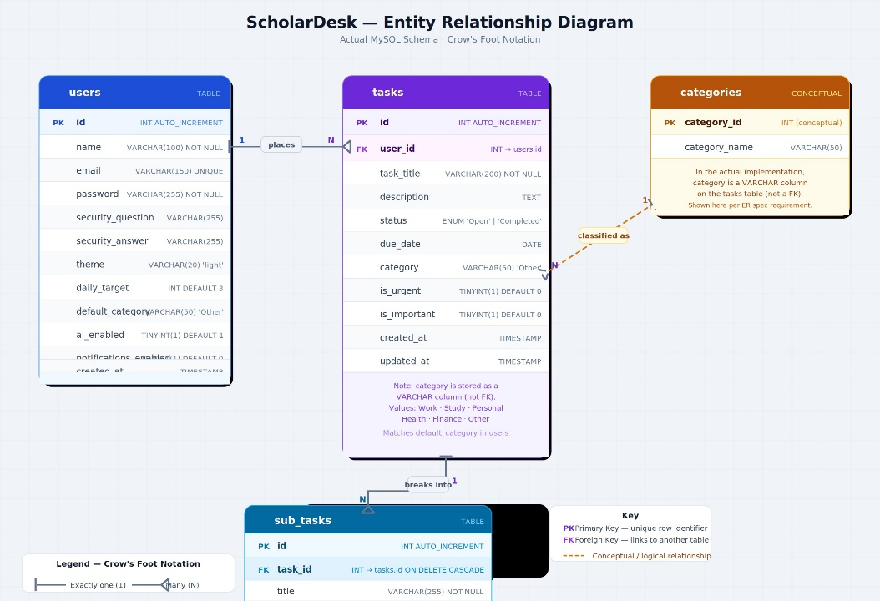

5.7 Database Design
Database design ensures structured and efficient data storage.

Users Table
Field Name | Data Type | Description
user_id | Integer | Primary Key
username | Varchar | User Name
email | Varchar | User Email
password | Varchar | Encrypted Password

Tasks Table
Field Name | Data Type | Description
task_id | Integer | Primary Key
title | Varchar | Task Title
description | Text | Task Description
deadline | Date | Task Deadline
status | Varchar | Completion Status
priority | Varchar | Task Priority
category_id | Integer | Foreign Key
user_id | Integer | Foreign Key

Categories Table
Field Name | Data Type | Description
category_id | Integer | Primary Key
category_name | Varchar | Category Name

5.8 Sequence Diagram
A sequence diagram shows the interaction flow between system components.

Example: User Login Sequence
User --> Frontend --> Backend API --> Database
Database --> Backend API --> Frontend --> User

Process
- User enters credentials
- Frontend sends login request
- Backend validates credentials
- Database verifies user information
- JWT token is generated
- Response is sent back to the user

5.9 User Interface Design
The system includes a responsive and user-friendly interface.

Main Pages

Login/Register Page
- User authentication
- Registration form
- Validation messages

Dashboard
- Productivity charts
- Task statistics
- Category-based analysis

Task Management Page
- Add/Edit/Delete tasks
- Filtering and searching

Category Management Page
- Category creation
- Category analysis visualization

5.10 Security Design
Security is implemented using:
- JWT authentication
- Password hashing
- Protected API routes
- Session validation
- Secure database operations
These mechanisms help protect user data and prevent unauthorized access.

5.11 Conclusion
The system design of the “Student Task Management System” provides a clear structure for application development and implementation. The modular architecture, secure authentication system, structured database design, and analytical dashboard integration ensure scalability, maintainability, and efficient performance.
The use of React.js, Node.js, Express.js, and MySQL helps in developing a modern cloud-based productivity management system with responsive interfaces and category-based analytical capabilities.

IMPLEMENTATION

6.1 Introduction
Implementation is the phase in which the designed system is converted into a fully functional application through coding and integration of various modules. The “Student Task Management System” is implemented using modern full-stack web development technologies to provide secure task management, category-based productivity analysis, and cloud accessibility.
The implementation phase includes frontend development, backend API development, database integration, authentication mechanisms, dashboard analytics, and deployment processes.

6.2 Development Environment
The project was developed using the following technologies and tools:
Technology/Tool | Purpose
React | Frontend Development
Node.js | Backend Runtime Environment
Express.js | Backend API Development
MySQL | Database Management
JWT | Authentication
HTML/CSS/JavaScript | User Interface Design
Visual Studio Code | Code Editing
Git & GitHub | Version Control
Cloud Hosting Platforms | Deployment

6.3 Frontend Implementation
The frontend of the application is developed using React.js. The frontend is responsible for handling user interaction, displaying dashboard analytics, and communicating with backend APIs.

6.3.1 React Component Architecture
The frontend follows a component-based architecture where each functionality is divided into reusable components.

Main Components
- Login Component
- Registration Component
- Dashboard Component
- Task Management Component
- Category Management Component
- Navigation Bar Component
This modular structure improves code maintainability and reusability.

6.3.2 User Interface Design
The user interface is designed to be:
- Responsive
- User-friendly
- Interactive
- Visually organized
CSS and React styling techniques are used to improve the overall user experience.

6.3.3 API Integration
The frontend communicates with backend services using REST APIs.

API Operations
- User authentication
- Task CRUD operations
- Category management
- Dashboard analytics retrieval
Axios or Fetch API is used for sending HTTP requests and receiving responses from the backend server.

6.4 Backend Implementation
The backend is developed using Node.js and Express.js. It handles business logic, API management, database communication, and authentication.

6.4.1 REST API Development
RESTful APIs are created for:
- User authentication
- Task management
- Category operations
- Dashboard analytics

Common API Methods
- GET
- POST
- PUT
- DELETE
These APIs enable communication between frontend and backend components.

6.4.2 Express.js Routing
Express.js routing is used to organize API endpoints efficiently.

Example Modules
- Authentication Routes
- Task Routes
- Category Routes
- Dashboard Routes
This structure improves backend scalability and maintainability.

6.4.3 Middleware Implementation
Middleware functions are used for:
- Authentication verification
- JWT token validation
- Error handling
- Request processing
Middleware improves security and centralized request handling.

6.5 Authentication and Security Implementation
Security is an important part of the application.

6.5.1 JWT Authentication
JWT (JSON Web Token) authentication is implemented to:
- Verify users securely
- Protect private routes
- Maintain authenticated sessions

Authentication Process
- User logs in
- Backend validates credentials
- JWT token is generated
- Token is sent to frontend
- Protected APIs verify token validity

6.5.2 Password Encryption
Passwords are encrypted before storing them in the database using hashing techniques. This improves user data security and prevents unauthorized access.

6.6 Database Implementation
The database layer is implemented using MySQL.

6.6.1 Database Connectivity
The backend establishes a connection with MySQL to:
- Store user data
- Manage tasks
- Store category information
- Retrieve dashboard analytics
Database queries are executed through backend services.

6.6.2 CRUD Operations
The application supports complete CRUD operations:

Create
Add new users, tasks, and categories.

Read
Retrieve tasks, dashboard statistics, and category data.

Update
Modify task details and status.

Delete
Remove tasks and unnecessary records.

6.7 Dashboard and Analytics Implementation
The dashboard module is one of the major components of the project.

Dashboard Features
The dashboard displays:
- Total tasks
- Completed tasks
- Pending tasks
- Overdue tasks
- Category-wise productivity analysis
- Productivity trends
Charts and visual elements are used to improve analytical understanding.

Category-Based Analysis
The system analyzes productivity based on task categories. This helps users:
- Identify workload distribution
- Track category performance
- Improve task organization

6.8 Cloud Deployment
The application is deployed on cloud platforms to provide online accessibility.

Deployment Benefits
- Anywhere access
- Better scalability
- Centralized data management
- Improved availability
The frontend and backend services are hosted separately and connected through APIs.

6.9 Error Handling
Error handling mechanisms are implemented for:
- Invalid login credentials
- Missing form inputs
- Unauthorized access
- Database failures
- API request failures
These mechanisms improve system reliability and user experience.

6.10 Challenges Faced During Implementation
Some challenges faced during development include:
- API integration issues
- Authentication handling
- Database relationship management
- Dashboard data visualization
- Cloud deployment configuration
These challenges were resolved through proper testing and debugging techniques.

6.11 Advantages of Implementation
The implemented system provides:
- Secure task management
- Interactive dashboards
- Efficient category analysis
- Cloud accessibility
- Scalable architecture
- Responsive user interface
- Organized backend structure

6.12 Conclusion
The implementation phase successfully transformed the system design into a functional cloud-based productivity management application. The integration of React.js frontend, Node.js and Express.js backend, MySQL database, and JWT authentication resulted in a secure and scalable application.
The implemented system effectively manages tasks, performs category-based productivity analysis, and provides users with interactive dashboards and cloud accessibility, making it a reliable productivity tracking platform.

7 ANALYTICS AND DASHBOARD

7.1 Introduction
Analytics and dashboard visualization are among the most important features of the “Student Task Management System”. This module helps users analyze productivity, monitor task completion trends, and understand workload distribution through interactive charts and statistical representations.
Unlike traditional task management systems that only store tasks, the proposed system provides meaningful insights using category-based analysis and dashboard visualization. These analytical features help users improve organization, productivity, and time management.

7.2 Dashboard Overview
The dashboard acts as the central interface of the application. It displays summarized information about tasks and productivity in a visually organized format.
The dashboard provides:
- Total number of tasks
- Completed tasks
- Pending tasks
- Overdue tasks
- Category-wise analysis
- Productivity trends
The dashboard is designed using responsive UI components and chart visualization techniques to improve readability and user experience.

7.3 Dashboard Components

7.3.1 Total Tasks Analysis
This section displays the total number of tasks created by the user.

Purpose
- Helps users understand workload size
- Provides quick productivity overview
- Improves task monitoring

7.3.2 Completed Tasks Analysis
This component displays the number of completed tasks.

Benefits
- Tracks productivity progress
- Encourages task completion
- Measures work efficiency

7.3.3 Pending Tasks Analysis
Pending tasks are tasks that are not yet completed.

Benefits
- Helps users identify remaining work
- Supports workload planning
- Improves task prioritization

7.3.4 Overdue Tasks Analysis
This section identifies tasks whose deadlines have passed.

Benefits
- Improves deadline management
- Helps reduce missed tasks
- Increases productivity awareness

7.4 Category-Based Analysis
Category-based analysis is one of the major functionalities of the system. Tasks are grouped into categories to provide meaningful productivity insights.

Features of Category Analysis
- Displays tasks grouped by categories
- Shows category-wise completion trends
- Helps identify workload distribution
- Improves task organization and planning

Example Categories
- Study
- Assignments
- Projects
- Personal Tasks
- Meetings
The analysis helps users understand which categories consume the most time and effort.

7.5 Productivity Trend Analysis
The system analyzes productivity trends over time using graphical representations.

Trend Analysis Features
- Daily productivity tracking
- Weekly task completion trends
- Monthly productivity overview
- Completion ratio analysis
These trends help users identify:
- Productivity consistency
- Delayed work patterns
- High workload periods

7.6 Graphical Visualization
Charts and graphical elements are used to improve dashboard readability and analytical understanding.

Types of Charts Used

Bar Charts
Used for:
- Category comparison
- Task completion statistics
- Productivity comparison

Pie Charts
Used for:
- Completed vs pending task distribution
- Category percentage analysis

Line Charts
Used for:
- Productivity trend visualization
- Weekly or monthly progress tracking
Graphical representations make analytical information easier to understand compared to textual data.

7.7 Dashboard Workflow
The dashboard workflow includes the following steps:
- User logs into the system
- Frontend requests dashboard data from backend APIs
- Backend retrieves task information from database
- Analytical calculations are performed
- Processed data is sent to frontend
- Dashboard charts and statistics are displayed

7.8 Technologies Used for Analytics
The analytics and dashboard module is implemented using:
Technology | Purpose
React | Dashboard UI
Node.js | Backend Processing
Express.js | API Handling
MySQL | Data Storage
Chart Libraries | Graphical Visualization

7.9 Advantages of Dashboard Analytics
The dashboard analytics module provides several advantages:
- Improved productivity monitoring
- Better workload visualization
- Easy tracking of task completion
- Enhanced organization using category analysis
- Improved deadline management
- Better decision-making for task prioritization
These features help users manage tasks more efficiently.

7.10 Limitations of Analytics Module
Some limitations of the analytics system include:
- Analytics accuracy depends on user-entered data
- Incorrect task categorization may affect analysis
- Productivity trends depend on consistent task updates
Despite these limitations, the dashboard provides meaningful productivity insights.

7.11 Future Improvements in Analytics
The analytics module can be further enhanced with:
- AI-based productivity recommendations
- Smart workload prediction
- Advanced filtering and reporting
- Time tracking analytics
- Notification-based productivity reminders
These enhancements can improve analytical accuracy and user experience.

7.12 Conclusion
The analytics and dashboard module significantly improves the functionality of the “Student Task Management System” by transforming raw task data into meaningful visual insights. The use of category-based analysis, productivity trends, and graphical visualization helps users monitor workloads, improve organization, and increase productivity.
The dashboard serves as a powerful analytical component that differentiates the proposed system from traditional task management applications by providing interactive and visually understandable productivity analysis.

8 TESTING

8.1 Introduction
Testing is an important phase in software development that ensures the system functions correctly, securely, and efficiently. It helps identify errors, validate functionalities, and improve the reliability of the application before deployment. The “Student Task Management System” was tested using multiple software testing techniques to verify the correctness of individual modules, integration between components, system performance, and user requirements.
The testing process was carried out on both frontend and backend modules to ensure smooth interaction between APIs, database operations, authentication mechanisms, and dashboard functionalities.

8.2 Objectives of Testing
The major objectives of testing are:
- To identify and fix software defects
- To validate system functionality
- To ensure secure authentication and data handling
- To verify API integration and database connectivity
- To improve system reliability and performance
- To ensure smooth user experience

8.3 Testing Methodologies Adopted
The following testing methodologies were adopted during project development:
- Black Box Testing
- White Box Testing
- Functional Testing
- Non-Functional Testing
- Integration Testing
- System Testing
- Validation Testing
- Authentication Testing
These testing approaches helped verify different aspects of the application.

8.4 Black Box Testing
Black Box Testing is a testing technique in which the internal code structure is not considered. The system is tested based on inputs and expected outputs.

Features Tested Using Black Box Testing
- Login functionality
- Registration process
- Task creation
- Category management
- Dashboard outputs
- Search and filtering

Black Box Testing Test Cases
Test Case ID | Module | Input | Expected Output | Result
BB01 | Login | Valid credentials | Login successful | Pass
BB02 | Login | Invalid password | Error message displayed | Pass
BB03 | Registration | Empty fields | Validation error | Pass
BB04 | Add Task | Valid task details | Task added successfully | Pass
BB05 | Add Task | Missing title | Validation message | Pass
BB06 | Category Filter | Select category | Filtered tasks displayed | Pass
BB07 | Dashboard | Task data available | Analytics displayed correctly | Pass

8.5 White Box Testing
White Box Testing focuses on testing the internal logic, code structure, and execution paths of the application.

Areas Tested
- API route execution
- Authentication middleware
- Database query handling
- Conditional logic
- Error handling mechanisms

White Box Testing Test Cases
Test Case ID | Module | Test Condition | Expected Result | Result
WB01 | JWT Validation | Invalid token | Access denied | Pass
WB02 | Task API | Null request body | Error handled properly | Pass
WB03 | Database Query | Invalid query execution | Error response generated | Pass
WB04 | Middleware | Unauthorized request | Request blocked | Pass
WB05 | Route Handling | Valid API request | Correct response returned | Pass

8.6 Functional Testing
Functional Testing verifies whether all application functionalities work according to requirements.

Functionalities Tested
- User registration
- Login authentication
- Task CRUD operations
- Category management
- Dashboard analytics
- Search and filtering
- Logout functionality

Functional Testing Test Cases
Test Case ID | Function | Expected Behavior | Result
FT01 | User Registration | New user account created | Pass
FT02 | User Login | User redirected to dashboard | Pass
FT03 | Add Task | Task stored in database | Pass
FT04 | Edit Task | Updated task displayed | Pass
FT05 | Delete Task | Task removed successfully | Pass
FT06 | Dashboard Analytics | Correct statistics shown | Pass
FT07 | Category Analysis | Proper category data displayed | Pass

8.7 Non-Functional Testing
Non-Functional Testing evaluates system quality attributes such as performance, security, usability, and reliability.

8.7.1 Performance Testing
Performance testing checks system responsiveness and API performance.

Tested Areas
- Dashboard loading speed
- API response time
- Database query execution

Result
The system responded efficiently under normal usage conditions.

8.7.2 Security Testing
Security testing verifies protection mechanisms within the application.

Tested Areas
- JWT authentication
- Password encryption
- Unauthorized access prevention
- Protected API routes

Result
The system successfully prevented unauthorized access and secured user sessions.

8.7.3 Usability Testing
Usability testing evaluates user experience and interface simplicity.

Tested Areas
- Navigation simplicity
- Dashboard readability
- Form usability
- Responsive design

Result
The interface was user-friendly and easy to navigate.

8.8 Integration Testing
Integration Testing verifies communication between different modules of the system.

Modules Integrated
- Frontend and Backend APIs
- Backend and Database
- Authentication and Protected Routes
- Dashboard and Analytics APIs

Integration Testing Test Cases
Test Case ID | Modules Tested | Expected Result | Result
IT01 | Frontend + Login API | Successful authentication | Pass
IT02 | Task API + Database | Task stored correctly | Pass
IT03 | Dashboard + Database | Correct analytics displayed | Pass
IT04 | Category API + Dashboard | Category analysis updated | Pass
IT05 | Authentication + Protected Routes | Unauthorized access denied | Pass

8.9 System Testing
System Testing verifies the complete application as a whole system.

Areas Tested
- Complete user workflow
- Dashboard functionality
- Task management operations
- Authentication system
- Cloud accessibility
- Responsive interface

System Testing Test Cases
Test Case ID | Scenario | Expected Output | Result
ST01 | Complete Login Workflow | User accesses dashboard | Pass
ST02 | Full Task Management Flow | CRUD operations successful | Pass
ST03 | Dashboard Analysis | Correct charts displayed | Pass
ST04 | Unauthorized API Access | Access denied | Pass
ST05 | Cloud Deployment Access | Application accessible online | Pass

8.10 Validation Testing
Validation testing ensures that the developed system satisfies user requirements.

Validation Areas
- Correct task management
- Accurate category analysis
- Dashboard functionality
- Secure login process
- Responsive design behavior

Result
The developed system successfully satisfied all major project requirements.

8.11 Bug Fixing and Debugging
Several debugging techniques were used during testing:
- Console debugging
- API response monitoring
- Database query validation
- Error logging
- Frontend debugging tools
Detected issues were resolved to improve stability and performance.

8.12 Testing Tools Used
Tool | Purpose
Postman | API Testing
Browser Developer Tools | Frontend Debugging
MySQL Tools | Database Testing
VS Code Debugger | Backend Debugging

8.13 Conclusion
Testing played a major role in ensuring the reliability, security, and performance of the “Student Task Management System”. Different testing methodologies such as black box testing, white box testing, functional testing, non-functional testing, integration testing, and system testing were successfully carried out.
The testing process verified that the application performs task management, category-based analysis, authentication, and dashboard visualization accurately and efficiently. The successful execution of all major test cases confirms that the system is stable, secure, user-friendly, and ready for deployment.

9 RESULTS AND DISCUSSION

9.1 Introduction
The results obtained from the implementation of the “Student Task Management System” demonstrate that the system successfully fulfills the objectives defined during requirement analysis and system design. The developed application provides secure task management, category-based productivity analysis, dashboard visualization, and cloud accessibility through an interactive and responsive web interface.
This chapter presents the outputs generated by the system, discusses the achieved functionalities, and evaluates the effectiveness of the implemented modules.

9.2 System Execution Results
The developed application was successfully executed and tested in a cloud-based environment. All major functionalities including authentication, task management, dashboard analytics, and category analysis operated correctly.
The system successfully performed:
- User registration and login
- JWT-based authentication
- Task CRUD operations
- Category management
- Dashboard analytics generation
- Search and filtering operations
- Cloud-based access

9.3 Login and Authentication Results
The authentication module successfully validated user credentials and protected unauthorized access using JWT authentication.

Features Verified
- User registration
- Secure login
- Token generation
- Session validation
- Protected routes

Result
The authentication system securely allowed only authorized users to access the application dashboard and APIs.

9.4 Task Management Results
The task management module successfully handled all CRUD operations.

Operations Performed

Create Task
Users were able to add new tasks with:
- Title
- Description
- Deadline
- Priority
- Category

Update Task
Users successfully modified task details and statuses.

Delete Task
Tasks were removed correctly from the system database.

Task Status Management
Tasks were categorized as:
- Completed
- Pending
- Overdue

Result
The task management system functioned accurately and efficiently.

9.5 Dashboard Analytics Results
The dashboard module successfully displayed analytical insights using graphical visualization techniques.

Dashboard Outputs
The dashboard displayed:
- Total tasks
- Completed tasks
- Pending tasks
- Overdue tasks
- Category-wise productivity analysis
- Productivity trends

Result
The dashboard provided meaningful visual insights that improved productivity tracking and task monitoring.

9.6 Category-Based Analysis Results
The category analysis module successfully grouped tasks according to categories and generated analytical summaries.

Category Analysis Features
- Category-wise task count
- Category completion statistics
- Workload distribution analysis
- Graphical comparison of categories

Result
Users were able to understand productivity distribution across different task categories effectively.

9.7 Search and Filtering Results
The search and filtering module successfully allowed users to:
- Search tasks by keywords
- Filter tasks by category
- Filter tasks based on completion status
- Sort tasks using priorities and deadlines

Result
The filtering system improved task accessibility and organization.

9.8 Database Operation Results
The MySQL database successfully handled:
- User data storage
- Task management records
- Category information
- Dashboard analytics retrieval

Result
Database operations were performed efficiently without data inconsistency issues.

9.9 API Performance Results
The backend APIs developed using Node.js and Express.js successfully processed requests and responses between frontend and database layers.

API Functionalities Verified
- Authentication APIs
- Task APIs
- Category APIs
- Dashboard APIs

Result
The APIs performed efficiently with proper request handling and response generation.

9.10 User Interface Results
The frontend developed using React successfully provided:
- Responsive layouts
- Interactive dashboards
- User-friendly navigation
- Real-time updates

Result
The interface improved user experience and application usability.

9.11 Cloud Deployment Results
The application was successfully deployed on cloud platforms, enabling online accessibility.

Deployment Benefits Achieved
- Remote access
- Centralized data management
- Improved availability
- Cross-device accessibility

Result
Users were able to access the application from different devices using internet connectivity.

9.12 Overall System Performance
The overall system performance was analyzed based on:
- Functionality
- Security
- Responsiveness
- Reliability
- Dashboard performance

Observations
- APIs responded efficiently
- Authentication remained secure
- Dashboard visualizations loaded correctly
- Database operations remained stable
- Task management operations were accurate

Result
The developed system performed reliably under normal operating conditions.

9.13 Advantages Achieve
The project successfully achieved several advantages:
- Secure cloud-based task management
- Interactive productivity dashboards
- Efficient category-based analysis
- Improved task organization
- Better productivity monitoring
- Responsive user interface
- Scalable system architecture
These features make the application more effective than traditional task management methods.

9.14 Limitations Observed
Some limitations identified during implementation include:
- Dependence on internet connectivity
- Analytics accuracy depends on user-entered data
- Limited advanced AI-based productivity insights
- Absence of real-time collaboration features
These limitations can be improved in future versions.

9.15 Discussion
The implementation results demonstrate that the “Student Task Management System” successfully integrates task management, category-based productivity analysis, and cloud accessibility into a single platform. The system effectively addresses the limitations of traditional productivity management applications by providing interactive dashboards and analytical insights.
The integration of React.js frontend, Node.js backend, Express.js APIs, MySQL database, and JWT authentication ensured smooth communication between all system components. The successful execution of dashboard analytics and category-based tracking proves the effectiveness of the proposed architecture and implementation methodology.

9.16 Conclusion
The results obtained from the developed system confirm that the project objectives were successfully achieved. The “Student Task Management System” provides an efficient, secure, and scalable solution for task organization and productivity monitoring.
The system successfully performs task management, category-based analysis, dashboard visualization, authentication, and cloud deployment while maintaining good performance and usability. The obtained results demonstrate that the application is reliable, functional, and suitable for productivity management purposes.

10 CONCLUSION AND FUTURE ENHANCEMENTS

10.1 Conclusion
The “Student Task Management System” was successfully designed, developed, tested, and deployed as a full-stack web application for efficient task management and productivity tracking. The project effectively combines modern web technologies, secure authentication mechanisms, cloud accessibility, and category-based analytical dashboards into a single integrated platform.
The developed system successfully addresses the limitations of traditional task management methods by providing:
- Centralized task organization
- Secure user authentication
- Category-wise productivity analysis
- Dashboard visualization
- Responsive user interface
- Cloud-based accessibility
The implementation of CRUD operations, JWT authentication, REST APIs, and dashboard analytics ensured smooth communication between frontend, backend, and database components. The use of React for frontend development and Node.js with Express.js for backend development provided scalability, flexibility, and efficient system performance.
The analytical dashboard became one of the strongest features of the project by transforming raw task data into meaningful productivity insights. Features such as completed task tracking, overdue analysis, pending task monitoring, and category-based productivity visualization improved the effectiveness of the system and differentiated it from traditional task management applications.
The testing phase verified that the application performs efficiently under different scenarios. Various testing methodologies including black box testing, white box testing, functional testing, integration testing, and system testing ensured the reliability, security, and stability of the developed application.
The cloud deployment of the system further improved accessibility by allowing users to access the application from different devices through internet connectivity. The project successfully demonstrates the practical implementation of modern full-stack web development concepts, database management, secure authentication, API integration, and dashboard analytics.
Overall, the “Student Task Management System” provides an effective and scalable solution for productivity management, helping users organize tasks efficiently, monitor workloads, and improve productivity through category-based analysis and visual dashboards.

10.2 Future Enhancements
Although the developed system successfully fulfills the current project objectives, several advanced features can be added in the future to improve functionality, scalability, and user experience.

10.2.1 AI-Based Productivity Suggestions
Artificial Intelligence can be integrated to:
- Recommend task priorities
- Suggest productivity improvements
- Predict workload trends
- Provide smart reminders
This would make the application more intelligent and adaptive.

10.2.2 Mobile Application Development
A mobile application version can be developed using cross-platform technologies to provide:
- Better accessibility
- Real-time notifications
- Mobile-friendly task management
This would improve portability and convenience for users.

10.2.3 Notification and Reminder System
Future versions can include:
- Deadline reminders
- Push notifications
- Email alerts
- Task completion notifications
These features can help users manage deadlines more effectively.

10.2.4 Calendar Integration
The application can be integrated with calendar systems to:
- Schedule tasks automatically
- Display deadlines visually
- Improve planning and organization
Calendar synchronization would improve time management capabilities.

10.2.5 Advanced Analytics
Future analytical enhancements may include:
- Time-based productivity tracking
- Weekly and monthly reports
- Advanced filtering and reporting
- Personalized productivity insights
These features can provide deeper analytical understanding.

10.2.6 Collaboration Features
Multi-user collaboration functionality can be implemented to support:
- Shared task management
- Team productivity tracking
- Group project organization
- Collaborative dashboards
This would expand the system for organizational and team-based usage.

10.2.7 Real-Time Synchronization
Real-time technologies can be integrated to provide:
- Instant dashboard updates
- Live task synchronization
- Real-time notifications
This would improve system responsiveness and user interaction.

10.2.8 Enhanced Security Features
Additional security improvements may include:
- Two-factor authentication
- OAuth login integration
- Advanced session management
- Activity monitoring
These features would further improve data protection and application security.

10.3 Final Summary
The project successfully demonstrates the implementation of a modern cloud-based productivity management system using full-stack web technologies. The integration of task management, category-based analysis, dashboard visualization, secure authentication, and cloud deployment resulted in a scalable and user-friendly application.
The proposed system not only improves productivity management but also provides meaningful analytical insights that help users organize work efficiently and monitor progress effectively. With future enhancements such as AI integration, mobile applications, and advanced analytics, the system can evolve into a more intelligent and comprehensive productivity management platform.

CONTRIBUTION TO ESG AND SUSTAINABLE DEVELOPMENT GOALS (SDG)

11.1 Introduction
The United Nations Sustainable Development Goals (SDGs) are a set of 17 global goals established under the 2030 Agenda for Sustainable Development. These goals address critical challenges including poverty, inequality, climate change, and the need for quality education and innovation. The Environmental, Social, and Governance (ESG) framework similarly provides guidelines for evaluating the broader impact of projects and technologies on society, the environment, and institutional governance.
The "Cloud-Based Student Task & Performance Tracker" is a technology-driven academic productivity system. While it is primarily a software project, its design, purpose, and implementation contribute meaningfully to several SDGs and ESG dimensions. This chapter maps those contributions explicitly.

11.2 Alignment with United Nations Sustainable Development Goals

SDG 4 – Quality Education
SDG 4 calls for inclusive, equitable, and quality education and promotes lifelong learning opportunities for all. This project directly supports this goal in the following ways:
- The system provides students with a structured, digital platform for managing academic tasks, deadlines, and study schedules, helping improve learning discipline and time management.
- The AI-powered task breakdown feature (using Google Gemini 2.5 Flash) generates actionable sub-tasks and personalized study strategies for each academic task, supporting self-directed learning.
- The productivity analytics dashboards provide students with insights into their academic habits, enabling data-driven improvements in study patterns and deadline management.
- The cloud-based architecture ensures that the system is accessible to students regardless of their location, supporting remote and flexible learning environments.
- The Daily Planner and Eisenhower Matrix features help students prioritize academic work effectively, building lifelong productivity habits that extend beyond formal education.

SDG 9 – Industry, Innovation, and Infrastructure
SDG 9 promotes building resilient infrastructure, fostering inclusive and sustainable industrialization, and encouraging innovation. This project contributes through:
- The application is built on modern, industry-standard technologies including Node.js, React.js, MySQL, REST APIs, and JWT authentication — demonstrating the use of innovative full-stack web development practices.
- Integration of Google Gemini AI for automated task breakdown represents an innovative application of generative AI in the academic productivity domain.
- The system follows a scalable, modular software architecture that supports future expansion, including mobile application integration, real-time notifications, and calendar synchronization.
- Cloud deployment on platforms such as Vercel and Render demonstrates the use of modern cloud infrastructure that is cost-effective, accessible, and scalable.
- The project demonstrates that small-scale academic innovations can be developed using open-source tools and cloud platforms, lowering barriers to technological participation.

SDG 10 – Reduced Inequalities
SDG 10 aims to reduce inequalities within and among countries. This system contributes to reducing educational inequalities by:
- Providing a free-to-use, accessible web application that requires only an internet connection, making academic productivity tools available to students from diverse socioeconomic backgrounds.
- Offering AI-based academic assistance that was previously available only through expensive tutoring or premium subscription tools, democratizing access to intelligent study support.
- Supporting students who lack access to physical academic planners or administrative support systems through a self-service digital alternative.

SDG 11 – Sustainable Cities and Communities
By enabling students to manage their academic and personal tasks through a cloud-based application, this project indirectly supports more sustainable and organized learning communities. Digital tools that reduce the dependence on paper-based planning materials contribute to more sustainable campus environments.

SDG 17 – Partnerships for the Goals
SDG 17 emphasizes leveraging technology and building partnerships for sustainable development. This project demonstrates the value of combining academic guidance with technological development by:
- Being developed as part of a Master of Computer Applications programme at B.M.S. College of Engineering, Bengaluru, representing a collaboration between academia and practical technology development.
- Using open-source frameworks and APIs (Node.js, React.js, Google Gemini), showcasing how academic projects can leverage global technology partnerships to deliver meaningful results.

11.3 SDG Contribution Summary Table

SDG Goal | Goal Description | Project Contribution
SDG 4 – Quality Education | Ensure inclusive and quality education for all | AI-powered task management, analytics dashboards, and productivity tracking support improved student learning outcomes
SDG 9 – Innovation & Infrastructure | Foster innovation and resilient infrastructure | Full-stack modern architecture, AI integration, and cloud deployment demonstrate technical innovation
SDG 10 – Reduced Inequalities | Reduce inequalities in access and opportunity | Free cloud-based platform democratizes access to AI-assisted academic productivity tools
SDG 11 – Sustainable Communities | Sustainable and organized communities | Digital task management reduces paper waste and supports organized campus communities
SDG 17 – Partnerships for Goals | Strengthen means of implementation | Academic-industry collaboration using open-source tools and APIs

11.4 Contribution to ESG Framework

11.4.1 Environmental (E)
The environmental dimension of ESG evaluates a project's impact on the natural world. This application contributes positively by:
- Reducing Dependency on Paper: By providing a fully digital platform for task management, scheduling, and academic planning, the system reduces or eliminates the need for paper planners, notebooks, and printed assignment sheets.
- Cloud Efficiency: Deployment on cloud platforms such as Vercel and Render, which operate on energy-efficient server infrastructure, is more environmentally sustainable than maintaining individual physical servers.
- Minimal Carbon Footprint: As a lightweight web application using optimized REST APIs and a React.js SPA (Single Page Application), the system minimizes data transfer overhead and computational energy consumption.

11.4.2 Social (S)
The social dimension of ESG evaluates the project's impact on people and society. Key social contributions include:
- Student Well-being: Reducing missed deadlines and organizing academic workload decreases stress and anxiety among students, contributing to improved mental well-being.
- Skill Development: The use of modern technologies (React.js, Node.js, JWT, REST APIs, Google Gemini AI) during development builds the technical competency of the developer, enhancing employability and professional readiness.
- Digital Inclusion: By making the system accessible via any modern browser and cloud-hosted for free access, the project promotes digital inclusion and equal access to academic tools.
- Educational Impact: The analytics and AI features encourage students to reflect on their academic habits, promoting a culture of continuous improvement and self-accountability.

11.4.3 Governance (G)
The governance dimension of ESG evaluates responsibility, transparency, and security practices in the project. This application demonstrates good governance through:
- Secure Authentication: The implementation of JWT-based authentication with bcrypt password hashing ensures that user data is protected according to industry security standards.
- Data Privacy: User data including task information, productivity statistics, and account details are stored securely in a MySQL database with user-specific access controls enforced through middleware.
- Transparent Architecture: The system follows RESTful API conventions, clear code structure, and modular design that makes the application auditable, maintainable, and extensible.
- Ethical AI Use: The AI module uses the Google Gemini API strictly for academic task assistance, with no collection or misuse of personal data, adhering to responsible AI usage principles.

11.5 Conclusion
The "Cloud-Based Student Task & Performance Tracker" aligns meaningfully with multiple United Nations Sustainable Development Goals, particularly SDG 4 (Quality Education) and SDG 9 (Innovation and Infrastructure). Through its digital-first approach, AI integration, and cloud deployment, the project promotes accessible education, reduces environmental impact, and demonstrates responsible governance practices. These contributions demonstrate that technology projects developed in academic settings can extend beyond their immediate scope to create positive social, environmental, and institutional value.

REFERENCES

Books
- Web Development with Node and Express, Web Development with Node and Express, O’Reilly Media, 2nd Edition, 2019.
- Learning React, Learning React, O’Reilly Media, 2020.
- Node.js Design Patterns, Node.js Design Patterns, Packt Publishing, 2020.
- Database System Concepts, Database System Concepts, McGraw-Hill Education, 7th Edition, 2019.
- Software Engineering, Software Engineering, Pearson Education, 10th Edition, 2016.
- Computer Networks, Computer Networks, Pearson Education, 5th Edition, 2013.

Research Papers and Journals
- Task Management and Productivity Analysis in Cloud-Based Applications, International Journal of Computer Applications, 2021.
- Web-Based Productivity Tracking Systems Using Modern JavaScript Frameworks, International Journal of Advanced Research in Computer Science, 2022.
- Cloud Computing Approaches for Productivity Management Systems, IEEE Transactions on Cloud Computing, 2020.
- Dashboard Visualization Techniques for Productivity Monitoring Systems, International Journal of Data Analytics, 2021.
- Secure Authentication Mechanisms Using JWT in Web Applications, International Journal of Information Security, 2022.

Websites and Documentation
- Node.js Official Documentation
- Express.js Documentation
- React Official Documentation
- MySQL Documentation
- JWT Introduction and Documentation
- MDN Web Docs
- GitHub Documentation
- REST API Design Guidelines

